**Project Report on the Hotel Booking Analysis**

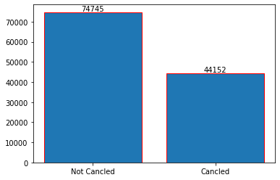

**Analysis Findings**

As we can see here that the Hotel cancelation numbers is massive, almost half of the Reservation or Booking not canceled. About 37% of the bookings are canceled due to many major reasons. We can find the Reasons Further below in the Report.

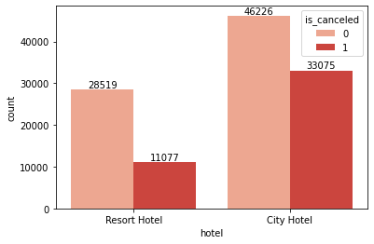

As we can see over here that the Resort Hotel Bookings are smaller as compared to the City Hotel, but the cancelation of the Hotels are more in the City Hotels as compared to the Resort Hotels. City Hotels almost have 71% canceled of the not canceled reservations, where the Resort Hotels have just 38% of the cancelation of the not canceled reservation. So the City Hotels are suffering a lot with this issue.

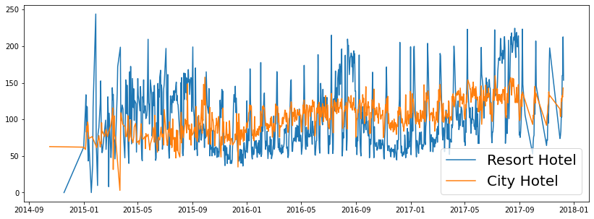

Now if we go further in the details of the Resort Hotel and the City Hotel, we find the pricing of the Hotel is the major issue for this. As we can see in this chart that the average pricing of the City Hotel is almost Constant as compared to the fluctuation of pricing in the Resort Hotels. The pricing of the Resort Hotels are on most of the days have more pricing as compared to the City Hotels. And the spikes or fluctuation in the graph are mainly due to the weekends or holidays. After the September 2017 the data is not sufficient so the fluctuation most of the times remains constant.

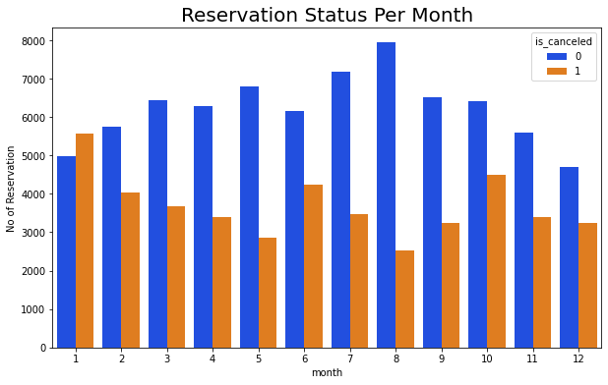

Here we find that on the month of the January the cancelation of the reservation in the Hotel industry are huge, even more than the booking not canceled. And on the August cancelation of the Hotels are at the least with the highest non cancel rate in the year. So we have to find the reason behind that in the further Analysis.

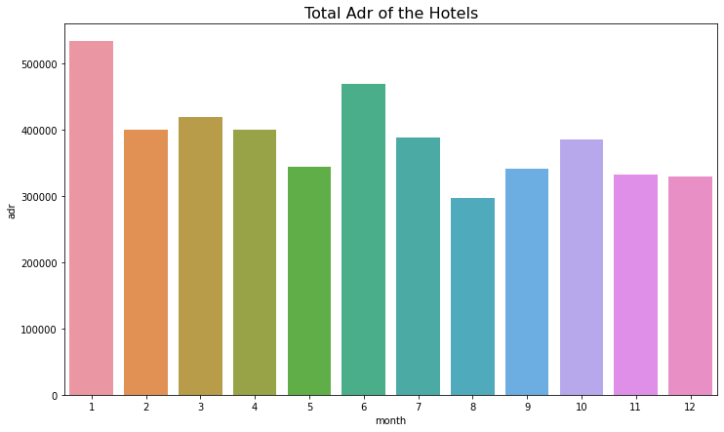

The main reason for the most cancelation and the least cancelation is due to the pricing of the Hotels on that particular month. Here on the January the pricing of the Hotels are at the most and on the August the pricing of the hotels are at its least.

So due to this it majorly impact on the cancelation of the reservation with January the most cancelation and the August the least cancelation.

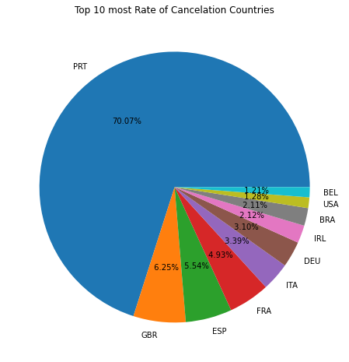

From the Top 10 most Cancelation Countries Portugal has the Highest Cancelation Rate as Compared to all the Countries in the World, of about the 70% of the Total Cancelation in the Hotel industry are done in the Portugal. As we can see the second highest is Unites Kingdom with 6.25% Cancelation rate in the whole World but still there is no Comparison between the Portugal and United Kingdom in the Cancelation rate.

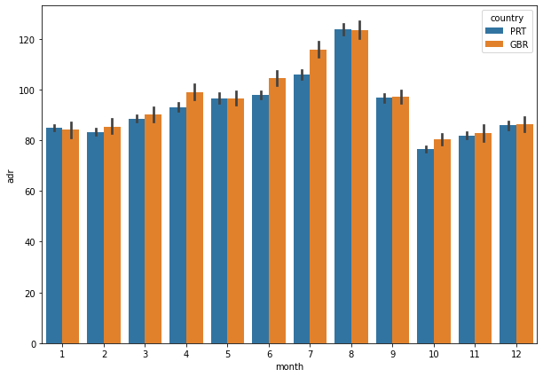

As we can see in the bar graph that the pricing of Portugal Hotels and the United Kingdom Hotels are almost the same. So the pricing of the Portugal Hotels are not the main issue in the Cancelation of the Hotels.

So probably the main issue is the facilities are not that much pleasing or effective in the Portugal Hotels, So Portugal will have to do the work in their facilities and decorum of their Hotels.

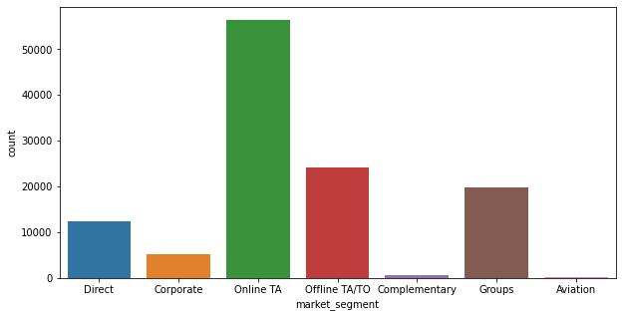

Now most of the Reservations of the Hotels are done on the Online platforms as compared to the Offline. The Total number of reservation from online is about 47% which is the most, on the other hand the Offline reservation is about 20% which is the Second highest, but we will go more deeper in to the Statistics of this.

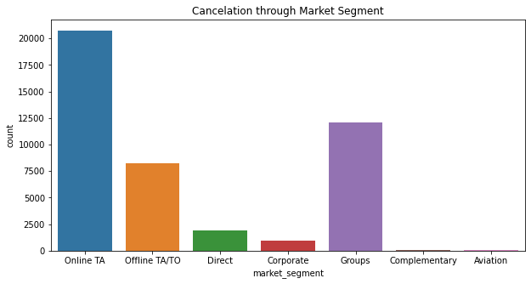

But here as per the Total Market Segment cancelation most of the reservation which is on the Online Segment are about 46% of them is been canceled which is the most cancelation as per Market Segment. Then the second most cancelation is from the Groups.

So Online have most reservation and the most cancelation together so the Hotels should have to work on the Online Segment to try to get the retention on the coming online reservations.

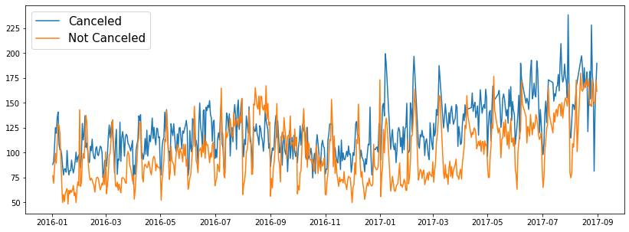

We also check for the difference in the pricing of the canceled and not canceled, and as we find here that pricing of the Hotels have the major effect on the cancelation of the Hotels.

The canceled price is more as compared to the not canceled price. So the Consumer cancels more when the price of the Hotels are increasing.

**Suggestions**

1. **The Pricing of the Hotels are directly effects on the cancelation of the Hotels. So to avoid this, the Pricing of the Hotel should be customer centric and to provide them coupons or discount.**
2. **Most of the cancelations are in City Hotels, So the City Hotels will have to improve the infrastructure and attracts the consumer on the weekends or in Holidays.**
3. **The Hotels have to mostly work on the January due to the most cancelation and the increase in the Price, so Hotels have to improve their marking in that phase of time.**
4. **You can also provide the Good Servicing and facilities to reduce their cancelation rate, the Portugal will mainly have to use this to improve their cancelation rate.**